Star / Snowflake / OLAP

1. a) Construct a star schema and snowflake schema

b) Perform ETL Operation for a case study

2.

1. Construct Cubes
2. OLAP Operations for a case study

3.

1. Construct star schema and snowflake schema
2. construct cubes for the same for a case study

4.

1. Construct star schema and snowflake schema
2. Perform OLAP Operations for a case study

5.

1. Perform OLAP Operations
2. OLAP Queries for a case study.

WEKA

6.a)

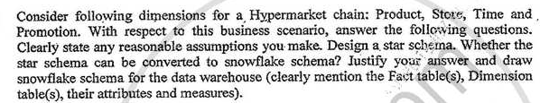

b) Using open-source tools to Implement Classifiers

7. a)

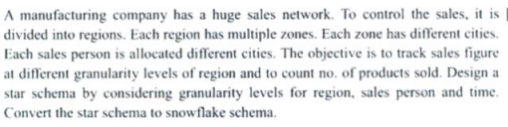

b)Using open-source tools to Implement Association Mining Algorithms

8. a)



b) Using open-source tools to Implement Clustering Algorithms

RANDOM

9. Implementation of page rank algorithm.